Sort Detective

Original lab by David B. Levine, Computer Science Department, St. Bonaventure University, http://nifty.stanford.edu/2002/LevineSort/

Background
As you know, if you double the size of the data set using a quadratic algorithm, it will do four times the work; by contrast, an O(N log N) algorithm will do a bit more than twice as much; and, a linear algorithm will do only twice as much work. (Are there any linear sorts?) As you also know, the characteristics of the input data set can affect the expected performance of many of our sorting algorithms. In this lab you will be a detective and discover which sorts are which by their behavior on different data sets. The six sorting algorithms under study are bubbleSort, heapSort, insertionSort, mergeSort, quickSort, and selectionSort.

Instructions
- Copy the 09_Heaps_SortDetective folder from R:/ to your directory. In jGrasp, navigate to SortDetectiveStudent. Open and run SortDetective1.java. (Notice that you cannot see the code for SortDetective.java)
- Play with the application. Notice that the labels on the buttons do not reveal which sort they execute. Notice also, that if you create a small list, then that list is shown to you in the console window.
- Devise a plan which will enable you to match the particular algorithms to the button names.
- Execute your plan. Keep a good record of your data.
- Conclude which button runs which sort. Support and justify your conclusions with data and graphs. Do NOT report data from every single experiment. A model report (with conclusions, data, a graph, and justification) from a similar but simpler lab on searching is shown below.

Sample Lab Report on Searching

Conclusions: Button Tau is Linear Search. Button Sigma is Binary Search.

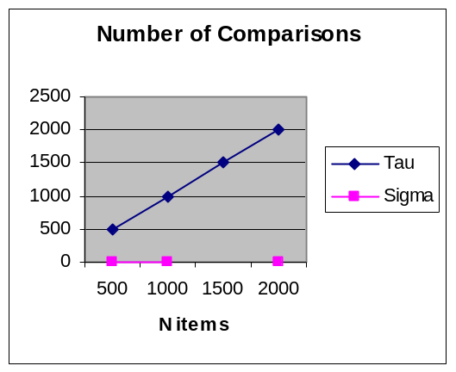Data: Graph:
 | Number of Comparisons
data size | Button Tau | Button Sigma
500 | 500 | 9
1000 | 1000 | 10
2000 | 2000 | 11

Justification: If we double the size of N, the comparisons in Button Tau also double, i.e., the relationship is linear. But for Sigma, the comparisons for increase go up by 1, i.e., the relationship is logarithmic. Button Tau must be a Linear Search. Sigma must be Binary Search.

